Sowmya Patlolla

1. Amazon Web Services (AWS): <http://54.174.187.133/jhanavi.html>

The following are the steps involved in Deploying a static website on AWS (public cloud) using Infrastructure (VM): Firstly, create a basic HTML file with your details.

* Step 1: Create an EC2 Instance on Amazon Console.

* Step 2: Give a name and create a new key pair and this will download the “.pem” file.

* Step 3: Select the security group allowing all three Traffics i.e. SSH, HTTPS, HTTP and click on Launch Instance this will create your Instance and make sure it is in running state and 2/2 checks have passed.

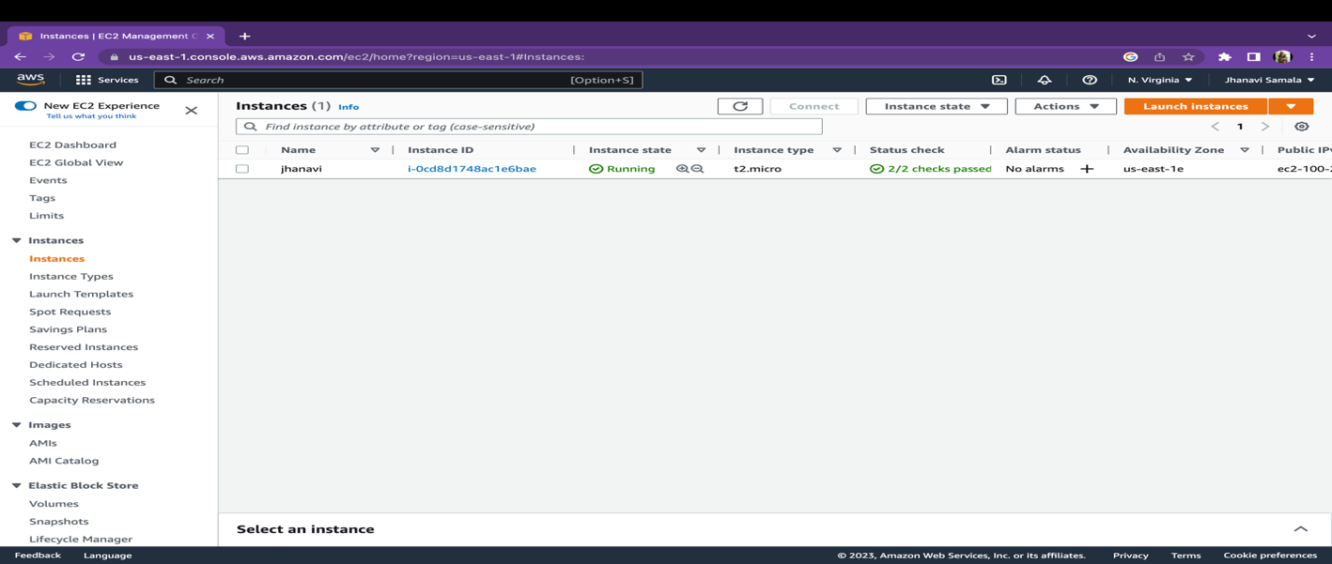

* Step 4: Go to-> Terminal change directory to Downloads (where the .pem file is downloaded) Select your instance and Click on connect ->SSH Client and copy the commands and paste it in terminal. Install apache2 change the directory to /var/www/html/ and add your html file and remove the rest of the files.

* Step 5: Go to-> Instances-> Copy the public address and paste it in different browser and your html page should appear.

* Step 6: Deploying a website using docker container:

Firstly, create a dockerfile, build docker image using

docker build -t html-server-image:v1 .

To run the command on Html container server

docker run -d -p 80:80 html-server-image:v1

This will show the first page of the file. Then install apache and start httpd service.

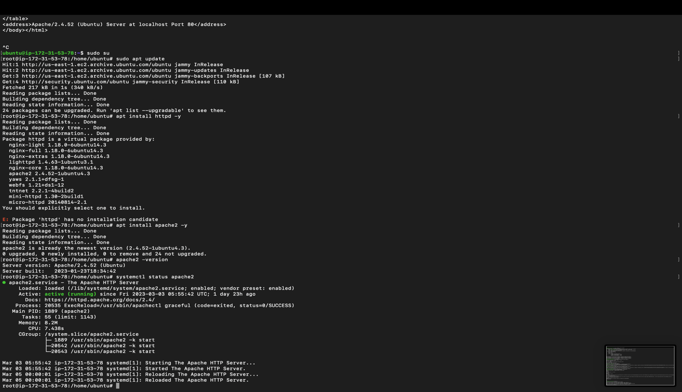

* Step 7: Go to-> Instances-> Copy the public address and paste it in different browser and your html page should appear.

**MS AZURE**

1. MS Azure: <http://20.163.3.207/jhanavi.html>

The following are the steps involved in Deploying a static website on MS Azure(public cloud) using Infrastructure (VM): Firstly, create a basic HTML file.

* Step 1: Login to MS Azure Console using your umsystem mail id & password. Create a new Virtual Machine.

* Step 2: Create a resource group and give the basic details like Virtual machine name, region, zone etc. Create a SSH Key and in inbound ports allow HTTP (80) along with SSH, then click on Review+create.

* Step 3: Check all and create the virtual machine(Click on Create).

* Step 4: A pop-up will appear and click on Download private key and create resource. The virtualmachine-demo_key.pem will be downloaded.

* Step 5: After creating your virtual machine is deployed.

* Step 6: Now you have to connect, Select your virtualmachine-demo and Connect with SSH.

* Step 7: Change the directory to downloads(where the key is been downloaded). Copy the above commands and connect to the virtualmachine-demo. Install apache2 and run it,change the directory and remove unnecessary files.

* Step 8: Go to-> virtualmachine-demo and copy the public address of the virtual machine and paste it in another browser and your HTML created file should appear.

**EPILOG:**

Lessons learnt:

Learning about various deployment models, such as virtual machines, containers, and cloud platform/function services, was made possible by the assignment. Cloud service providers and their offerings, such as Amazon Web Services (AWS), Microsoft Azure, and Google Cloud Platform, were also covered (GCP). We discovered that virtualization offers flexibility and isolation, enabling the use of several operating systems on the same hardware. Similar advantages are provided by containers, but with less administrative work and quicker starting. An even more streamlined method is offered by cloud platform/function services, which let developers concentrate on the application code without worrying about the supporting infrastructure.

Fun Part:

Examining several cloud services and discovering their possibilities was one of the enjoyable aspects of the work. We loved experimenting with the many functions and offerings provided by several cloud service providers, including Amazon, Azure, and GCP. As a result, we were able to compare the functionality. Finally, the assignment provided an opportunity to learn about emerging technologies in the cloud computing space.

Challenging part:

Configuring virtual machines and containers was one of the most difficult aspects of the task. This requires a thorough comprehension of the underlying technology as well as the capacity to resolve problems that came up during setup. We had to familiarize ourselves with various virtualization and containerization systems and learn how to setup them using command-line tools. Overall, the task was difficult yet rewarding, requiring a thorough knowledge of cloud computing technology.